Frequently Asked Questions

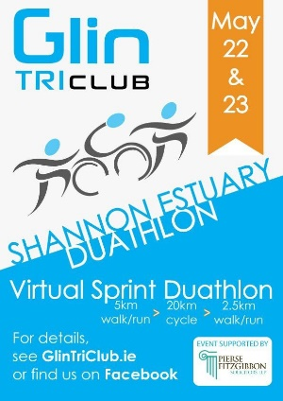
Where is the event taking place?
This is a virtual duathlon so can take place in your locality but remember to stay with the COVID-19 restrictions for training and the event. We do recommend that you plan your route in advance in order to enjoy the event in a safe manner.
What is a sprint duathlon?
A sprint duathlon is an athletic event which consists of a run/walk followed by a cycle followed by a final run/walk. It is traditionally completed all in one go. Timing start from the start of the run and part of the skill set required is to reduce the time spent transitioning from one leg to another in as short a time as possible. So, it is recommended to practice transition technique!
What about Results?
It is up to each individual/team to submit their results onto the Results base website and the Glin Tri Club will issue each finisher with a completion certificate. Timing can be recorded using any of the usual GPS based tracking devices. Some can be linked directly to Results base or alternatively a photo of the finishing time on a personal device can be uploaded onto Results base. (Further details supplied by Results base on registration).
Are there prizes?
AS this is a virtual event there are no winner prizes. The objective is to provide a training structure and the experience of taking part in a duathlon. Duathlon is a great way to refine your racing tactic and use your bike/run strength to influence your race. By racing an early season duathlon, it will benefit your triathlon season overall.
Am I covered by insurance?
If you are a member of Triathlon Ireland or Cycling Ireland this will provide insurance. Common sense applies.
When will my pack arrive?
You will receive a virtual pack on registration and your event neck warmer will be posted out nearer to the event date.

